**Management And Advanced Queries Outputs**

**Q1. Write a query to find the number of students in Computer Science Engineering Department.**

**Output:**

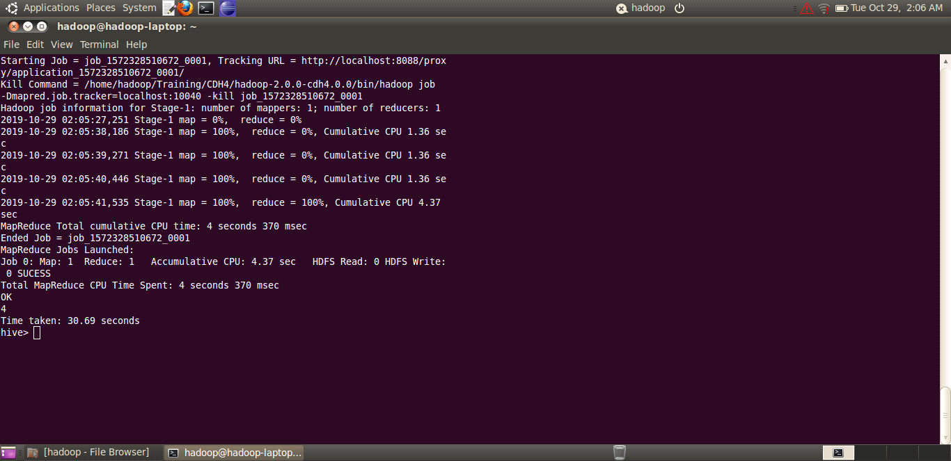

**Q2. Write a query to find out the student details from Electronic and Computer Engineering who paid the fee on a particular date.**

**Output:**

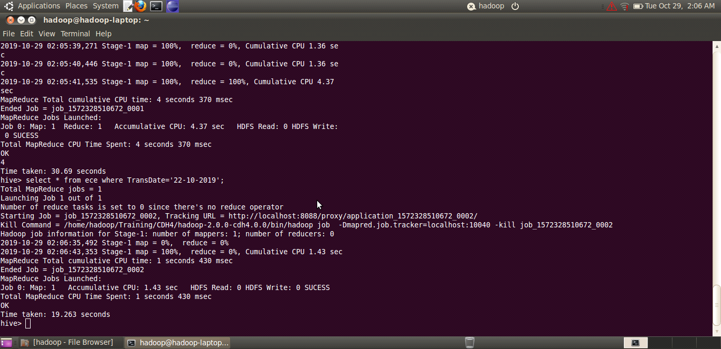

**Q3.** **Write a query to display the count of students who paid full fee without any due from Bio-Technology.**

**Output:**

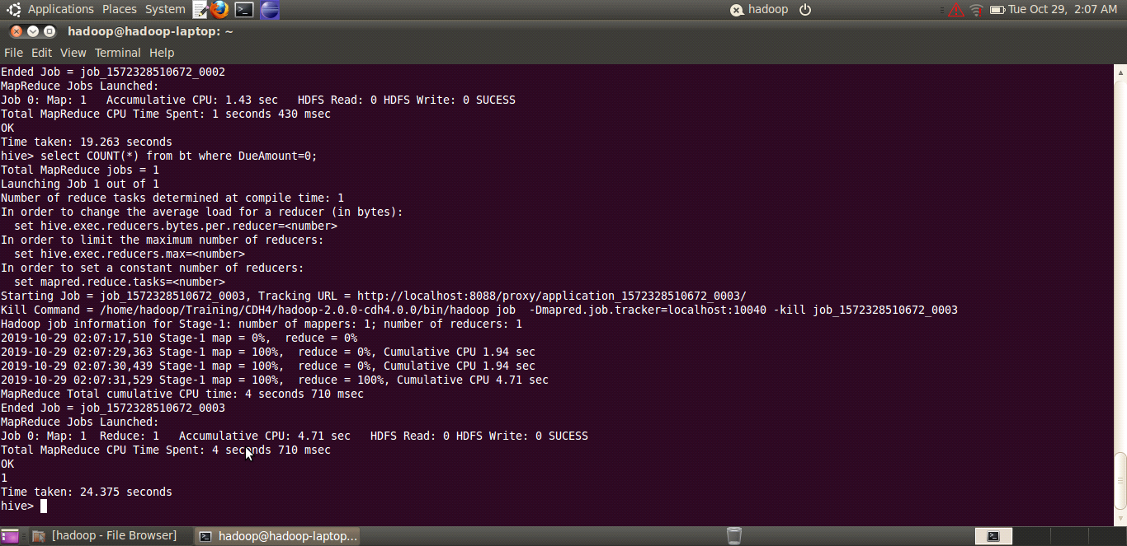

**Q4. Write a query to display the student details from Computer Science Engineering who had due greater than a particular amount.**

**Output:**

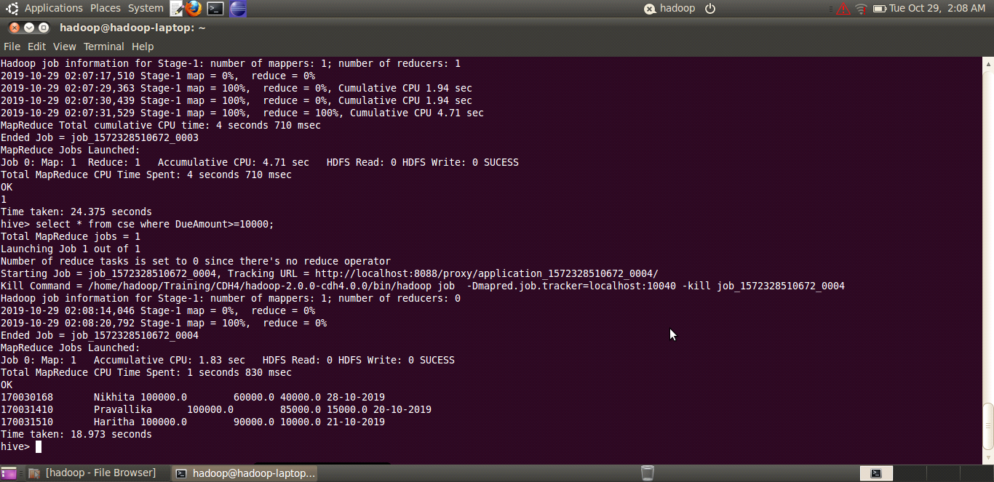

**Q5. Write a query to display the count of students in Electronic and Computer Engineering who have a fee due.**

**Output:**

